Project Title: Natural Disaster intensity analysis and

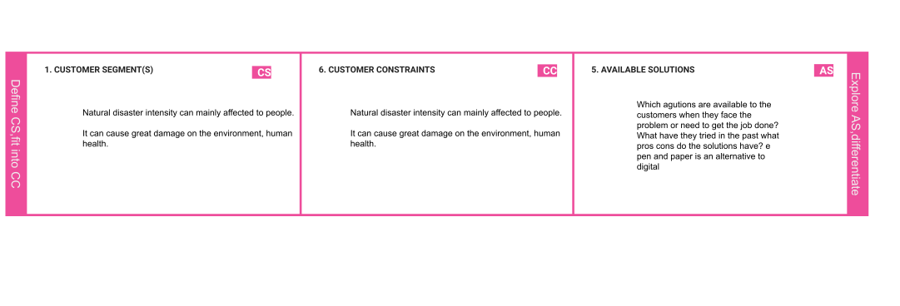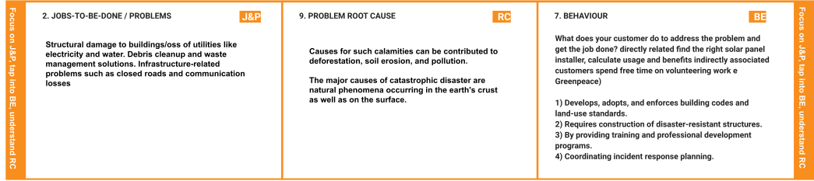

classification using Artificial intelligence Project Design Phase-I - Solution Fit Team ID: PNT2022TMID28524

|  |  |  |  |  |
| --- | --- | --- | --- | --- |
|  | **3. TRIGGERS TR**  Humans impact the physical environment in many ways: overpopulation, pollution, burning fossil fuels, and deforestation. Changes like these have triggered climate change, soil erosion, poor air quality, and undrinkable water. | **10. YOUR SOLUTION SL**  If you are working on an existing business, write down your current solution ﬁrst, ﬁll in the canvas, and check how much it ﬁts reality.  If you are working on a new business proposition, then keep it blank until you ﬁll in the canvas and come up with a solution that ﬁts within customer limitations, solves a problem and matches customer behaviour.  **Emotional instability, stress reactions, anxiety, trauma and other psychological symptoms are observed commonly after the disaster and other traumatic experiences.**  **These psychological effects have a massive impact on the concerned individual & also on communities.** | 1. **CHANNELS of BEHAVIOR CH**    1. **ONLINE**   What kind of actions do customers take online? Extract online channels from #7   * 1. **OFFLINE**   What kind of actions do customers take ofﬂine? Extract ofﬂine channels from #7 and use them for customer development.  **ONLINE:**   * + 1. They seek technical support or the experts opinion on such matters via the internet   . 2)They organize strategic meetings with other authoritarians to help in decision making.  **OFFLINE**:   * + - 1. They involve in a series of planning activities to ensure the smooth progress of the monitoring and preventing the impacts of the natural phenomenon |  |
| **4. EMOTIONS: BEFORE / AFTER EM**  **Emotional instability, stress reactions, anxiety, trauma and other psychological symptoms are observed commonly after the disaster and other traumatic experiences.**  **These psychological effects have a massive impact on the concerned individual & also on communities.** |